ALGORITHM TO PREVENT COLLISIONS BETWEEN ROBOTIC BEES
Juliana Lalinde  Universidad EAFIT  Colombia  jlalindev@eafit.edu.co | Isabel Urrego  Universidad EAFIT  Colombia  iurregog@eafit.edu.co | Mauricio Toro  Universidad EAFIT  Colombia  mtorobe@eafit.edu.co

ABSTRACT
Bees are fundamental for the proper development of an ecosystem. Their population decline is an alarming phenomenon we are currently facing, and it has brought popularity to the idea of developing robotic bees, that can fulfill their functions. A key factor in the execution of this project is constant and effective monitoring that ensures effective distribution.
This distribution determines the benefit that can be obtain, but it depends of a proper execution: there can not be collision between bees that move in the same three-dimensional space. The need to be alert of the risk of possible collisions is the reason for the development of an algorithm that analyses possible accidents. As a base case for the development of the algorithm we used the city of Bello, where bees are in risk of colliding if they are less than one hundred meters apart.

Keywords
Collisions, Hashing, Hash Table, Hash Functions, Static Hashing

ACM CLASSIFICATION Keywords
CCS → Theory of computation → Design and analysis of algorithms → Streaming, sublinear and near linear time algorithms → Bloom filters and hashing

1. INTRODUCTION
Bees have been catalogized as one of the most important animals for ecosystems. They pollinate different plants, which contributes to the reproduction of different species and the production of aliment vital for living beings. There are cases in which an entire species reproduction depends on the behavior of bees.
Nowadays, various factors have led to their population decrease, putting at risk many species and ecosystems. This has alerted specialists and has brought the development of ideas to solve the problem. One key idea is the invention and use of robotic bees.
These robotic bees would complete the same functions of real bees, becoming a help to ensure the constant reproduction of different plants. Achieving this present a challenge: bees need to be properly programmed and evaluated to be actioned, a process that brings need factors to be considered.
One of the most important factors to take into account is the risk of collisions between the bees, and the fact that in order to optimize their functions bees need to have a significant distance while operating [1]

2. PROBLEM
This projects objective is to implement a time efficient algorithm that helps with one of the key factors in the development of robotic bees. The factor that is going to be taken as a base is the risk of collisions.
Knowing this, the main objective is to design a program that allows the detection and notification of bees that are less than one hundred meters apart. The input about the bees will be their coordinates in a three-dimensional space.

3. RELATED WORK
3.1 Spatial Hashing
This algorithm is used to detect collisions between objects on both two- and three-dimensional spaces with the help of a data structure known as a hash table. Having a set of elements, hash tables associate proper keys of each element to a value. Additionally, they have a hash function that return an index to be able to access an element in the table [2].
When two elements are saved in the same index in the table then there is a collision, and this is exactly the case that relates hash tables with our bee collision problem.
In Spatial Hashing, the table works as a subdivision of the space and if there is a collision then it means that there are at least two elements in the same subdivision.
This algorithm helps to avoid the use of a brute force solution that would have to compare the distance between every pair of elements that are part of the set given. Comparison is only made between subdivisions that contain more than one element, because the number of elements in the same location indicates a possible collision. Through this process the algorithm guaranties a greater efficiency in the same execution time [3].
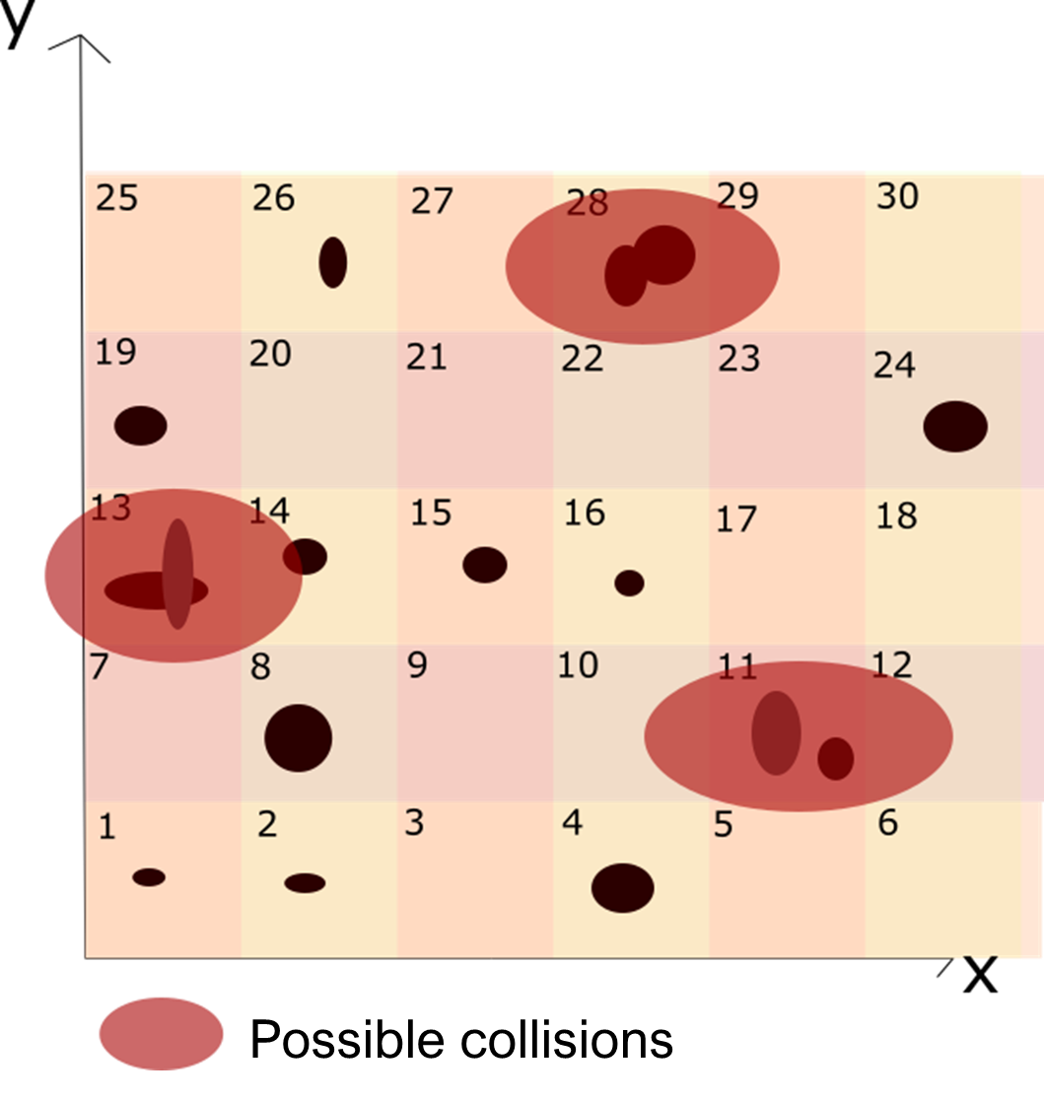
Figure 1: Example of Spatial Hashing in two dimensions

3.2 AABB trees
This method is used to verify if there are possible collisions between different objects, with the help of AABBs.
AABBs are basically boxes that contain objects, this way the axes between different objects align. Instead of taking an object with all its regularities
AABBs son básicamente cajas que contienen objetos y de esta manera los ejes entre diferentes objetos se alinean. Es decir, en vez de tomar un objeto con todas sus regularidades, se toma el objeto como algo que está contenido entre ciertas coordenadas en x, ciertas en y y otro rango en z si se habla de tres dimensiones. Esto es para disminuir notoriamente el número de comparaciones que se deben hacer para identificar una colisión, pues usando AABBs solo se tendría que tener en cuenta un rango en cada eje. [4]
No obstante, comparar cada AABB cuando son numerosos elementos podría resultar muy poco efectivo y es por esto que se acude a los árboles. Estas estructuras de datos se forman asociando elementos (hojas) y juntándolos en una misma raíz que en este caso sería también un AABB. La ventaja está en el momento de revisar las3 posibles colisiones, pues simplemente se miraría si un objeto tiene riesgo con una raíz y solamente si la respuesta es sí, se procede a revisar cada “hoja” de la raíz para detectar dónde están las colisiones. Finalmente, no se estarían comparando todos los AABBs entre ellos, sino haciendo un número más reducido de verificaciones basadas en el árbol que se armó por medio de asociaciones de AABBs. [2]
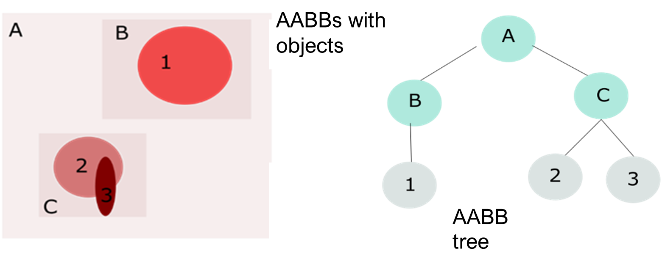
Figure 2: Example of the use or AABB trees

3.3 R-tree
It was formulated by Antonin Guttman in 1984. A tree is a data structure that simulates the shape of a real tree, an empty tree is used to build a R-tree, into which the elements that need to be saved are added.
In the R-tree structure the leaves correspond to the smallest rectangles that contain the geometrical object that need to be explored, an element is inserted on an R-tee with the following process: the object moves down the tree, from the root to the leaves, checking in which of the following rectangles belongs the object. This is done until the element reaches one of the leaves, where it is added. To search for a specific object the same process is followed, except that in the end it returns the leave that contains the searched objects. This procedure is used to identify possible collisions between objects, if by the end of the search there are no objects on the leave you reach then there are no collisions [6].

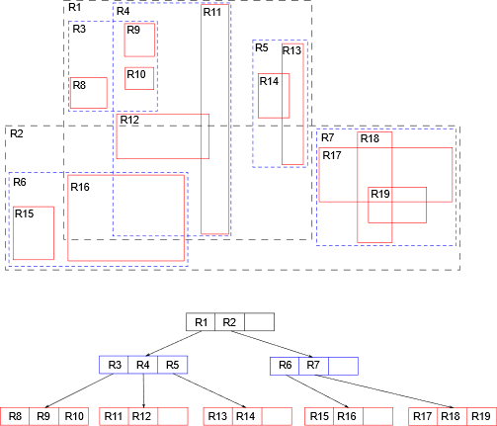

Figure 3: Example of the use of R-trees

3.4 Octree
An Octree is a hierarchical data structure that divides space, it is used for objects located in a three-dimensions. It works by dividing the space in eight cubes, which are also divided into eight cubes individually. This process of division is applied until a designated cube size is reached, if we are working with collisions we would want to reach the smallest object size or the minimal distance between two objects to avoid a collision. The objects that are contained within the same cube are at risk of collision and must be evaluated [7].
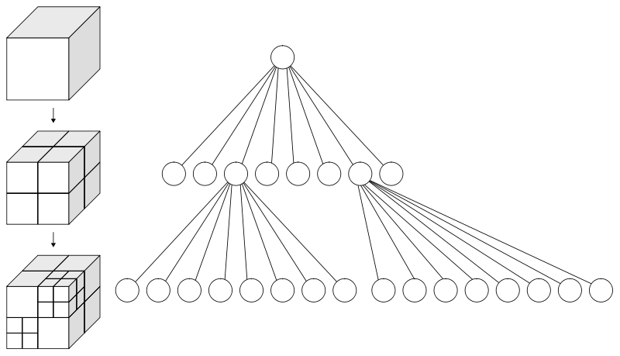
Figure 4: Example of the use of Octrees

3.5 Heap Tree
This data structure is often used as a sorting algorithm known as Heap Sort. To sort the values, you build a binary tree with the condition that the parent is always either bigger or lower than the children. Hence, the root of the tree always represents the maximum or the minimum value among the whole tree depending on the criteria chosen, leading to two different kinds of Heap Tree, the Minimum and the Maximum Heap Tree. [9]
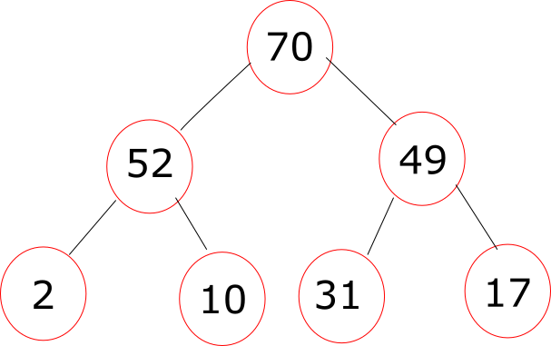
Figure 5: Example of Max Heap Tree

4. Spatial Hashing in three-dimensions
The first data structure that we implemented to solve the problem is Spatial Hashing, based on Hash Tables. It works by dividing the space into cube grids, in which each one has a diagonal of 100, and associating each of the bees into a cube based on their coordinates. This size guarantees that the biggest distance between two bees inside is 100 meters.
The different cubes are associated with an index, that helps identify the elements that are within its range. Every element, in this case the coordinates of a bee, that is added to the grid is referred to as a key and must go through a Hash Function that return a number that matches the index of one of the cubes. Using this division, we can then quickly affirm that all the elements that share the same key are in a collision risk, and we can also lower the number of comparisons between objects that are in different cubes using a simple strategy: we only need to compare the distance between bees that are in adjacent cubes if the number of bees in the cube is 1. Otherwise, there will be a warning of the bees sharing the same cube without comparisons needed.
Although the idea was based on the concept of Hash Tables, it was decided to use another implementation thinking the division of space as a Linked List three-dimensional array to make the distribution of the bees easier. The linked list allows to save more elements inside one cube grid to collect the bees with collision risk.

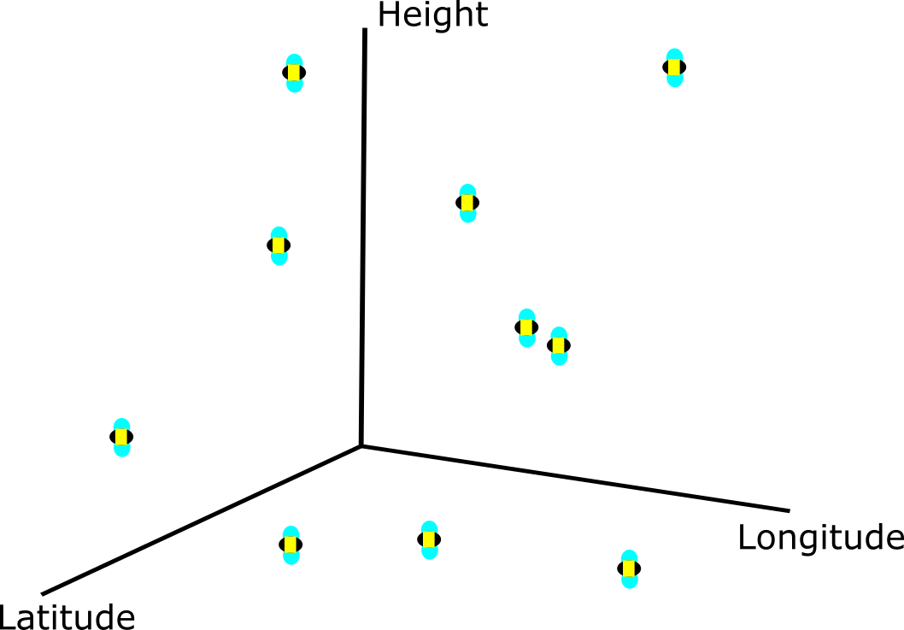

Figure 5: Example of the interpretation of the input

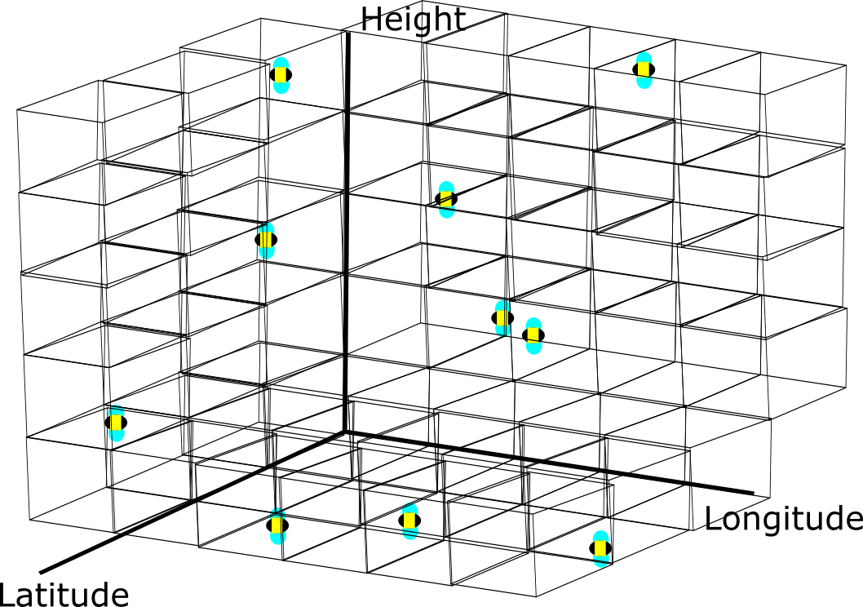

Figure 6: Bees classified by their coordinates using Spatial Hashing

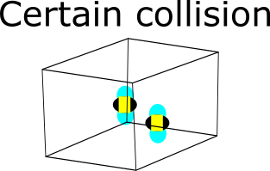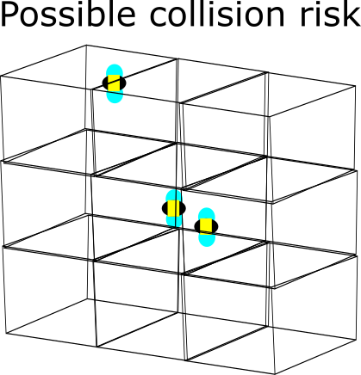
Figure 7: Example of the possible collisions between different cubes

4.1 Operations of the data structure
The main operations used with Spatial Hashing are [8]:
*The images of the operations show a two-dimensional plane (the bees have two coordinates). By the real implementation of the algorithm we will use a Euclid Plane, which adds another dimension, but the operations will do the same as shown.
- createHashTable: used to create a new hash table. Each grid will represent a cube which has different keys representing the coordinates of the bees and a index associated. This function creates a table of the given size and the grids will be the divisions of the plane. Additionally. the creation of a new Hash Table includes a Hash Function which pairs a key (bee) with a grid (cube). To guarantee that the table has the needed size we first read the data and save the maximum and minimum values of each coordinate to determinate the dimensions of our three-dimensional array.
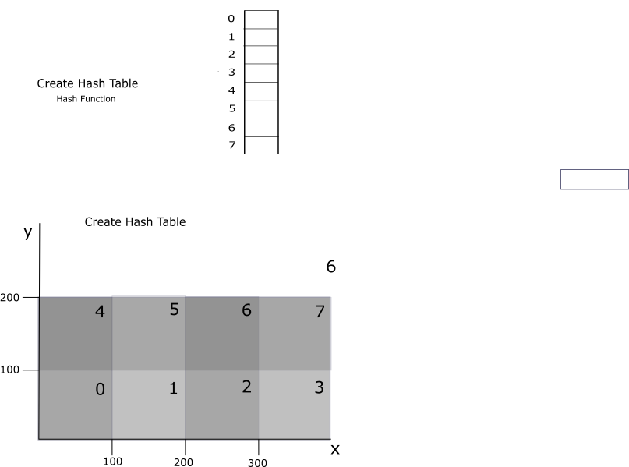
Figure 8: createHashTable
- hashSearch: used to search a key in hash table. Given the coordinates of a bee, this operation uses the hash function to know which grid should contain this element and searches if the element is effectively there.
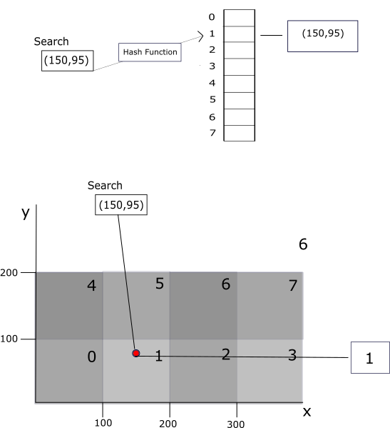
Figure 9: hashSearch
- Search: says which keys (bees) belong to a specific index (grid).
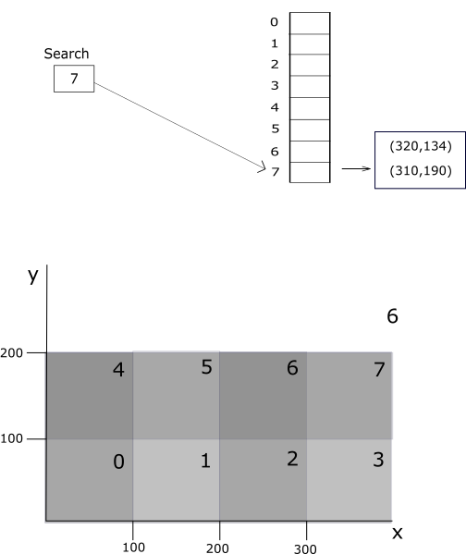
Figure 10: Search
- hashInsert: inserts a new element with help of a key. Given the coordinates of a bee, this operation uses the hash function to add the element to the cube where the coordinates are included.
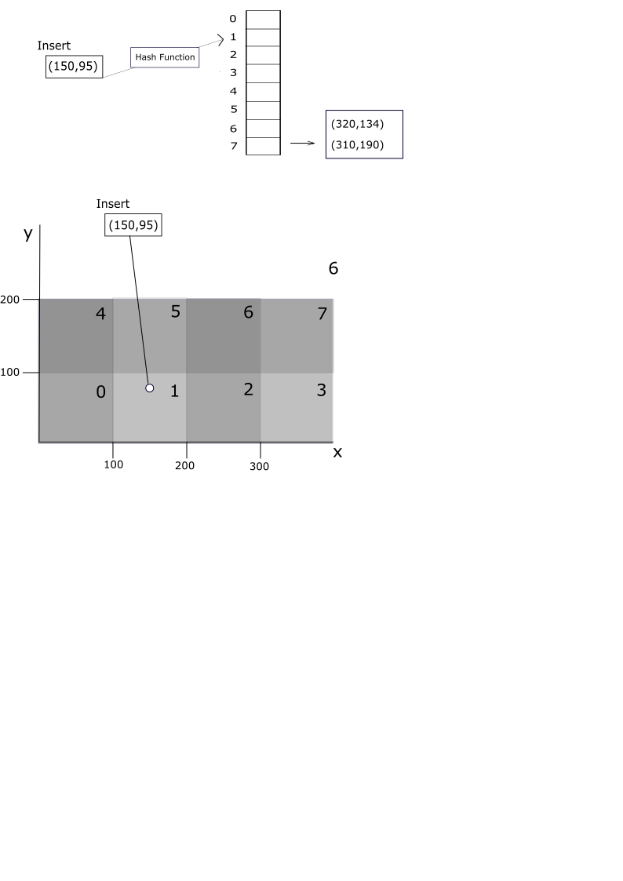
Figure 11: hashInsert
- hashDelete: deletes a value from hash table. It uses the hash function to know from which grid the element should be deleted and proceeds to remove it from the table.
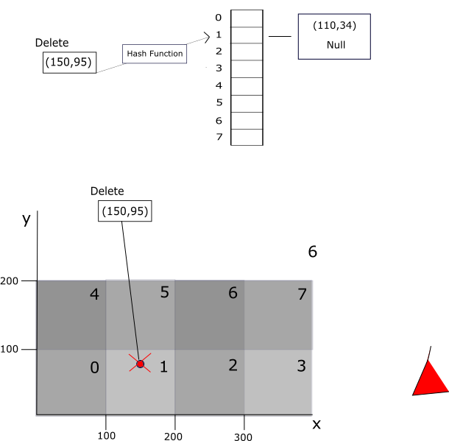
Figure 12: hashDelete
- deleteHashTable: Deletes the whole table
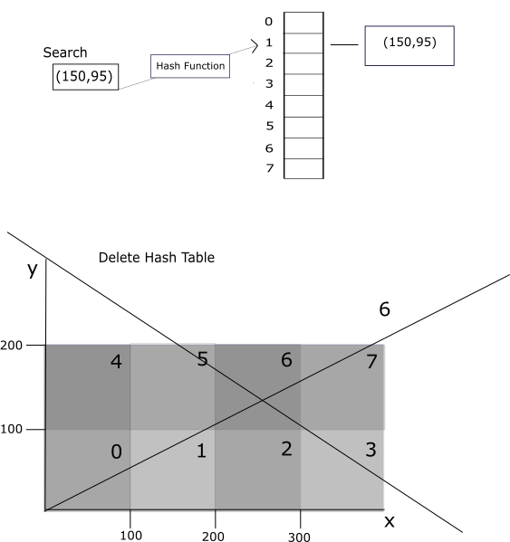
Figure 13: deleteHashTable
4.2 Design criteria of the data structure
While looking for the solution for the problem we put time efficiency as the main criteria. We read about the different data structures, always thinking how we could reduce the number of comparisons. Our first idea was to separate the bees into different groups defined by their coordinates. In that order, we would have different divisions of the Euclidean space and the comparisons needed would be limited by the number of bees sharing the same cube. That is how we realized that we could use the concept of hash tables to solve the problem.
Spatial Hashing allowed us to divide the space equally and place the bees considering their three coordinates, it also lowered significantly the number of comparisons that needed to be made. Additionally, we decided to work with Lists within the cubes to guaranty that any number of bees could be contained without a limit. This Lists also allow a more dynamic execution for the comparisons that still need to be executed.
4.3 Complexity analysis
Function | Average Complexity | Worst Case Complexity | Explanation of the variables
createHashTable | O(n) | O(n) | n is the amount of bees
hashSearch | O(n) | O(n) | n is the size of the list inside the cube grid
hashDelete | O(n) | O(n) | n is the size of the list inside the cube grid
hashInsert | O(n) | O(n) | n is the size of the list inside the cube grid
4.4 Execution Time
This are the times

4.5 Memory used
4.6 Result analysis
These results prove the use of Spatial hashing as optimal solution for this problem. Nevertheless, there is one possible problem and is the case where there is only one bee inside the cube grid, because it might collide with others in adjacent cubes and is not going to be considered.
One possible solution to fix this would be to have a list of the grids that have only one bee at the moment and at the end it would be known which parts of the table needed to be verified with adjacent ones. Otherwise, it would be needed to transverse the whole array looking with the positions of size 1, what would significantly increase the time complexity and be the opposite of optimal.
Thus, there is another function needed to calculate the Euclid distance within the bee that is alone and the bees in adjacent cubes, which would lead to a worst-case time complexity of O(n^2) where n is the number of bees.
Even if our principal objective was time efficiency and not memory, we see that a hash table is not a good option if memory is wanted to be saved.

5. Heap Sort
Subsequently, we tought about another possible solution that

REFERENCES
1. Klein, K. Robotic bee could help pollinate crops as real bees decline. NewScientist. Recuperado el 26 de Agosto de 2018: https://www.newscientist.com/article/2120832-robotic-bee-could-help-pollinate-crops-as-real-bees-decline/
2. Narasimha Karumanchi. 2018. Data structures and algorithms made easy in Java: data structure and algorithmic puzzles, Madinaguda, Hyerabad: CareerMonk Publications.
3. MacDonald, T. Spatial Hashing. Gamedev.net. Recuperado el 25 de Agosto de 2018: https://www.gamedev.net/articles/programming/general-and-gameplay-programming/spatial-hashing-r2697/
4. James. Introductory Guide to AABB Tree Collision Detection. AZURE FROM THE TRENCHES. Retrieved on August 25 of 2018: https://www.azurefromthetrenches.com/introductory-guide-to-aabb-tree-collision-detection/
5. Antonin Guttman. 1984. R-trees: a dynamic index structure for spatial searching. In Proceedings of the 1984 ACM SIGMOD international conference on Management of data (SIGMOD '84). ACM, New York, NY, USA, 47-57. DOI=http://ezproxy.eafit.edu.co:2079/10.1145/602259.602266
6. Jane Wilhelms and Allen Van Gelder. 1992. Octrees for faster isosurface generation. ACM Trans. Graph. 11, 3 (July 1992), 201-227. DOI=http://ezproxy.eafit.edu.co:2079/10.1145/130881.130882

7. Hosam M. Mahmoud. 2000. Sorting: A Distribution Theory, Wiley- Interscience Publications.

